

Head Architecture and Design Limited

Scope and Fee Proposal
for
Lane Crawford
"Food as Fashion"
at
IFC, PP, TS & CR
Hong Kong

Thursday 5th February 2026

PROJECT INFORMATION:

Proposal Date: 5 February 2026
Project No: 868-418
Designer: HEAD Architecture and Design Limited
Client: The Lane Crawford Joyce Group
Project Name: Food As Fashion (F&B and Retail)
Project Locations: IFC, Pacific Place, Time Square, Canton Road, Hong Kong.

INTRODUCTION:

The brief is for the planning and design of four integrated food retail and light F&B destinations within Lane Crawford's Hong Kong store portfolio; a strategic, first-in-market concept where fast-moving, trend-driven food retail meets cultural programming and social experiences. This is not a traditional food hall or gourmet grocery; this is food as fashion, food as social currency; where hype product drops, cult brands, exclusive collaborations, and rotating F&B concepts create FOMO-driven traffic, build community, and reposition Lane Crawford as a curator of culture beyond fashion.

We understand this project requires creating an umbrella design concept adaptable across four distinct locations (totalling ~10,499 sqft),

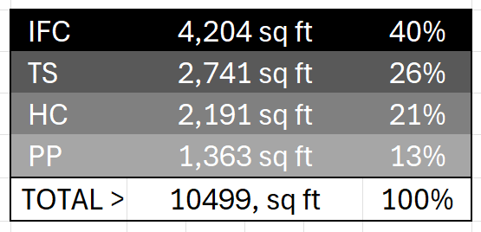

The challenge is to deliver complete technical documentation for landlord approvals and F&B licensing, designing for extreme operational flexibility; supporting rapid brand changeovers, influencer activations, and content-generation moments while maintaining the high productivity and the curatorial aesthetic that Lane Crawford is famous for.

With staggered launches across Q3 2026 (September 1-30), we recognise the need for parallel workstreams, aggressive timeline management, and a deep understanding of Hong Kong's regulatory environment and luxury retail operations.

This is about reimagining what a Lane Crawford destination can be, and we're ready to make it happen!

SCOPE OF WORK:

Work Stages

Please refer to the attached program supplied by the Client.

Inception

- Carry out a visual site survey and take a photographic record
- Agree an outline budget from the Client for the works
- Agree with the Client the basis for charging fees
- Prepare a preliminary Design Programme for the project based on the Master Programme provided by Lane Crawford showing submission of deliverables, interfacing with the Client and payment schedule.
- Determine the brief in sufficient detail for subsequent stages to commence

Inception Deliverables Format
Scope of Service and Fee Proposal | A4
Preliminary Design Programme | A3

A Inception
Kick off meeting
Client Brief
Initial Ideas

B. Concept Design

Prepare and submit documents including spatial and concept presentation to explain overall concept of interior design concept and style of four spaces and circulation, with special attention paid to F&B as a brand creation, Relationship/ Transition between Food & Drink and Food Retail, SKU density, Cashier/ Cashless, Delivery/ Information Counter, Promotion areas (HPP), Signage, Flexibility of Furniture and Display

- Competitor analysis of market leaders and influencers
- Carry out a full site survey including existing lighting levels in all areas
- Identification of issues in current site
- Proposal for Lane Crawford common area brand as it applies to the store design
- Presentation of innovative planning and display ideas
- AutoCAD Layout planning design, circulation and visual sight lines
- High-low display diagrams, category diagrams
- Mood boards to indicate interior design concept and style
- Coordinate with E&M design drawings
- 3D and sketch renderings of principal vistas and entrances
- Concept materials sample boards
- Branding analysis and branding and graphics concept
- Liaise with Photographic Consultant for concept images
- Liaise with Lane Crawford E&M and Fire Service consultants
- Prepare program for Developed Design
- Presentation to Lane Crawford management in Hong Kong

Concept Design Deliverables Format
Site Report | A4
Competitor and Market Analysis | A4
Layout Plans and diagrams | A3
Mood boards | A3
3D sketches | A3
Graphic Design analysis and concept | A3
Materials Sample Boards | A3
Presentation materials | A3
Program | A3

C. Developed Design

Analyze the Client’s feedback and incorporate into the Developed Design. Prepare and submit Developed Design documents including spatial and concept presentation to explain the detailed design. Inform the Client of any major decisions that are needed and receive any amended instructions in a prompt manner.
Analyze the Client’s comments on the Concept Design and identify and report on outstanding issues.
- Prepare a Developed Design consisting of drawings and specifications sufficient to indicate the final elevational arrangement, materials and appearance of all areas
- Prepare lighting design proposal indicating lux levels in all areas
- Branding analysis and branding and graphics Developed Design
- Liaise with Photographic Consultant for final image selection
- Prepare 3D computer renderings of main public spaces and entrances
- Source potential manufacturers and suppliers
- Coordinate with E&M and FS consultants and Graphic Designer
- Coordinate with Client’s nominated HVAC, Security, IT, Kitchen, Signage and Materials suppliers
- Presentation of the Developed Design to the Client in Hong Kong
- Inform the Client of any major decisions that are needed and receive any amended instructions

Developed Design Deliverables Format
Developed Design mood boards | A3
Setting out plans | A3
Finishes plans | A3
Reflected ceiling plan with lighting proposal | A3
Elevations | A3
Graphic Design and Branding final version | A3
Photographic image selection and location | A3
3D computer renderings | A3
Materials boards | A3
List of potential suppliers | A4

D. Construction Documentation

Construction Documentation to be prepared by HEAD, including AutoCAD plans, elevations and details sufficient for Lane Crawford to prepare the written tender and pre-selected Tenderers to prepare a costing estimate. Incorporate any design work undertaken by sub-contractors and suppliers and consultants. HEAD to check and comment on package so that Client can amend before Tender.
- Prepare Construction Drawings and Specification sufficient to obtain final quotations from contractors.

Documentation Deliverables Format
Construction drawings | A3

E. Tender
- Answer and queries from Tenderers on Construction Drawing package
- Attend Tender interviews as arranged by Client and assess their potential to successfully complete the project

F. Construction Supervision
- Allow for weekly site visits during the construction period by Designer
- Prepare weekly Photographic Record and Site Minutes
- Advise on site coordination issues as required
- Prepare and issue any outstanding design information
- Prepare Defects List and co-ordinate with Client’s comments for Contractor to rectify
- Check and approve Contractor’s ‘As-Built’ drawings by Designer

Construction Deliverables Format
Additional drawings as required | A3
Defects List | A4

G Practical Completion
- Check complete works and issue final certificate of practical completion to close out
- Receive final payment

FEE AND PAYMENT SCHEDULE

HEAD Architecture and Design Limited to be paid a lump sum of HK$3,300,000. This is anticipated to be 10% of an estimated total construction sum of HK$ 33M.

This will be broken down into the following installments as per payment schedule below:

Payment Schedule:

Stage Scope Payment Fee % HK$
--------------------------------------------------------------------------------------------------------
A Contract Award (Inception) 12/02/2026 10% 330,000
B Concept Design 15/03/2026 30% 990,000
C Developed Design 15/04/2026 20% 660,000
D Construction Documentation 15/05/2026 15% 495,000
E Tender 15/06/2026 10% 330,000
F Construction Supervision 15/07/2026 10% 330,000
G Practical Completion 15/09/2026 5% 165,000
--------------------------------------------------------------------------------------------------------
Total 100% 3,300,000

Table Indicative of fees based on area and cost
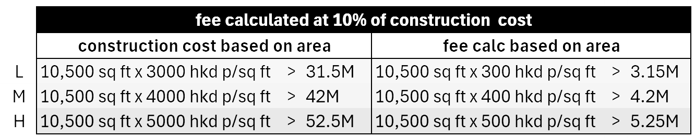

AGREEMENT

All payments to be made in strict accordance with the payment schedule

We, The Lane Crawford Joyce Group, accept the proposal made by HEAD Architecture & Design Limited and agrees to be bound by the terms and conditions specified hereinabove. HEAD Architecture & Design Limited agrees that it shall not vary the work or charges without prior written authority from the Client.

Fees: As presented in Fee Proposal
Expenses: As presented in Fee Proposal
Bank: The Hongkong and Shanghai Banking Corporation Limited
Account: 043-3-034949

> Sign below:

_________________________ _________________________________
Signed for and on behalf of Signed for and on behalf of
HEAD Architecture and Design Ltd Lane Crawford Joyce Group
17/F., Casey Building
38 Lok Ku Road
Sheung Wan
Hong Kong Hong Kong
Ph. (852) 2869 5725 Ph. (852)
Fax. (852) 2578 4230 Fax. (852)
Email: mike@headarchitecture.com Email:
DATE: 05/02/2026 DATE:

APPENDIX A: CONDITIONS OF APPOINTMENT

1.0 Consultants

  - HEAD Architecture (known herein as “The Designer”) will advise on any requirement for independent consultants. The Designer will assist in directing and integrating their work. Kris Vervaeke is expected to act as Photographic Consultant. His Fee Proposal will be based on the copyright purchase of images for exclusive use by Lane Crawford. He will be appointed and paid by the Client.

2.0 Responsibilities

2.1 The Designer shall not make any material alteration, addition to or omission from the approved design without the knowledge and consent of the Client, except if it is found necessary during the fit out for construction reasons, in which case he shall inform the Client without delay.
2.2 The Designer shall inform the Client if he has reason to believe the total authorized expenditure or contract period are likely to be materially varied.
2.3 The Client shall be responsible for approving all design matters within 7 calendar days and without delay and confirm the same by signing the drawings submitted by the Designer for approval to ensure the timely execution of the project. The Client will sign off design drawings at the completion of each Stage. If the Client has comment on a given design, the Client should clarify these points in writing with the Designer. The Designer should revise and resubmit the design according to the Client’s comment. The approval time for the resubmission should count from the resubmission date. If the client does not comment on the design within 7 calendar days, the design drawings should be considered approved by the Client.
2.4 The scope of the Design Services shall exclude all Mechanical and Electrical consultants work, licensing consultants work and kitchen design work. Graphic Design and Branding work is included. The Designer shall not be responsible for the design or program coordination of other consultants unless under HEAD’s Scope of Works. The scope of Design Services excludes design of any concessions or sub-tenanted counters or areas other than the generic design surrounding these areas.
2.5 The scope of the Design Services shall exclude all applications, notices and fees required by all statutory bodies and service utilities including licensing applications. The Designer shall not be responsible for notifying and obtaining any written approvals which may be required by the landlord, government, the building management and adjoining owners such as the MTR Corporation, unless otherwise stated.
2.6 The Designer shall not be responsible for administering the construction contract or program.
2.7 The Designer’s rights and obligations under this Agreement may not be assigned or otherwise transferred in whole or in part without the prior written consent of the Client.

3.0 Specialist sub-contractors and suppliers

3.1 The Designer may recommend that specialist suppliers, such as lighting manufacturers, become involved in the specification and detailed calculations of the design，subject to the prior approval of Client. The Designer will not be responsible for the detailed design or performance of their product. The contract with any such suppliers will be signed directly with the Client, not through the designer.

4.0 Delay and changes in instructions

4.1 Extra work and expense incurred by the Designer at any stage caused by the Client’s delay in giving instructions, delays in operations, changes in design, phased contracts or any other action by the Client or other party beyond the control of the Designer shall be additionally charged on a time basis. This will charged as follows:

Position | Staff | Hourly Rate (HK$) | Day Rate (HK$) | Weekly Rate (HK$)
Director | Mike Atkin | 3,000 | 12,000 | 54,000
Technical Director | Jonathan Rodgers | 2,000 | 8,000 | 36,000
Design Director | Dr Vera Kleesattel | 2,000 | 8,000 | 36,000
Information Manager | Ruth Nolasco | 1,000 | 5,000 | 22,500

4.2 The appointment by the Client of the Designer may be terminated at the end of a Design Stage by either party on the expiry of 14 days written notice, at which time the Designer shall be entitled to remuneration in accordance with the Fee and Payment Schedule.

5.0 Extensions of Time

5.1 If any part or parts of the Work Stages are delayed beyond the Date of Completion stated in the Fee and Payment Schedule:
- by delay on the part of the Client
- by delay on the part of any consultants engaged by the Client
- by reasons beyond the control of the Designer，e.g. force majeure
- then the Client and the Designer will decide upon a fair and reasonable extension of time for completion of the Scope of Works. Additional time required by the Designer will be charged at the rates listed in Clause 4.1 or as mutually agreed.
6.0 Abandoned Works and the Termination of the Contract

6.1 Where the design of the works is cancelled or postponed on the Client’s instructions or the Designer is instructed to stop work indefinitely at any time, the commission may be deemed to be abandoned and fees for partial service shall be due. Refer to the Fee and Payment Schedule.

6.2 Where the commission is abandoned or if the Client gives instructions at any time prior to completion not to undertake any part of the work, fees for partial service in respect of the whole or part of the works shall be charged for all service already carried out. Refer to the Fee and Payment Schedule.
6.3 Both parties agree that should any dispute under this Agreement arise between the parties, every effort shall be made by the appropriate management of the respective parties to resolve such dispute in good faith.

7.0 Mode and Scheduling of Payment

7.1 Apportionment of fees between stages of service shall be strictly in accordance with the Fee and Payment Schedule.
7.2 Payments shall be made in full within twenty-eight (28) days of presentation of invoice for each stage. Any sums that remain unpaid at the expiry of 28 days from the date of presentation of account shall bear interest thereafter at 0.3% per day of the contract sum. Accounts on which a query is not raised within 7 days of presentation shall be deemed to be approved as presented. HEAD reserves the right to temporarily cease work in the event of non-payment of outstanding invoices.
7.3 All cheques and bank transfers shall be made payable to HEAD Architecture and Design Limited.

8.0 Out of Pocket Expenses

8.1 In addition to the fees under any other part of these conditions, the Designer shall be reimbursed for all reasonable expenses actually and properly incurred in connection with the commission.
8.2 Printing, reproduction, material or purchase costs of all documents, drawings, models, photographs, and other records, including all those used in communication between Designer, Client, Consultants are included.
8.3 Local and international traveling expenses, accommodation and related expenses relevant to the project will be for the account of the Client.

9.0 Intellectual Property

9.1 The provisions of this Section shall apply without prejudice to the Designer’s lien on drawings against unpaid fees.
9.2 The Client only owns Copyright of all drawings/artworks, and of the work results executed from/by these drawings/artworks for this target location that defined in the contract upon Client's full payment of the sum stated in contract, unless otherwise agreed. The Client shall pay The Designer a loyalty payment if using the same drawings/artworks but execute these in other project locations.
9.3 The Designer reserves the using rights of the project photos of designers own works but only for Designer's own marketing purpose, unless otherwise agreed.
10.0 Contract and Drawing Package Language

10.1 The Drawing Package will be in English only.

11.0 Jurisdiction

11.1 Any contract made on these terms shall in every respect be governed by the laws of Hong Kong, and the parities hereby submit to the exclusive jurisdiction of the local courts of Hong Kong.

APPENDIX B: SITE LOCATIONS
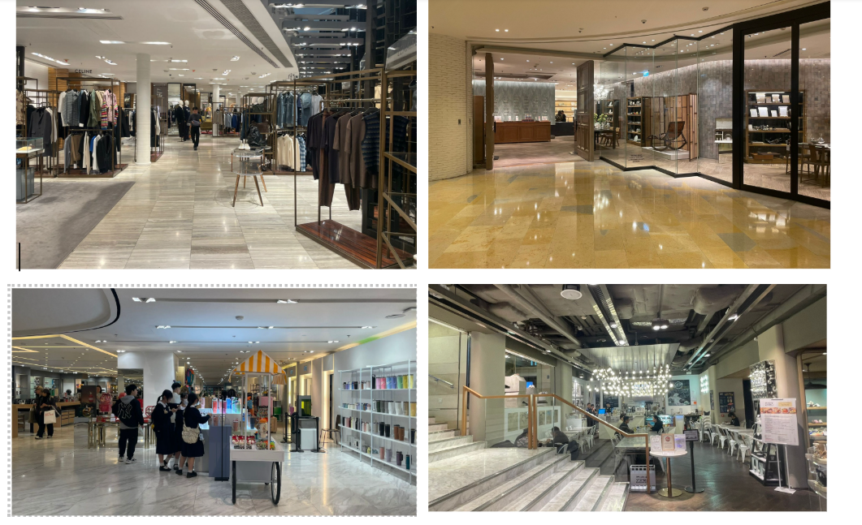

Implementation Locations & Timeline
- IFC
  - Size: 4,204 sq ft (Retail: 3,004 sq ft / F&B: 1,200 sq ft)
  - License: Light Refreshment (With Extraction) + Liquor
  - Target Retail Launch: July 15, 2026
  - Target F&B Launch: September 15, 2026
- Pacific Place
  - Size: 1,363 sq ft (Retail: 863 sq ft / F&B: 500 sq ft)
  - License: Light Refreshment (Without Extraction) + Liquor
  - Target Launch: September 1, 2026
- Times Square
  - Size: 2,741 sq ft (Retail: 1,741 sq ft / F&B: 1,000 sq ft)
  - License: Light Refreshment (With Extraction) + Liquor
  - Target Launch: September 30, 2026
- Canton Road
  - Size: 2,191 sq ft (Retail: 1,228 sq ft / F&B: 963 sq ft)
  - License: Light refreshment restaurant license (Current)
  - Target Launch: September 30, 2026

Area Comparisons for each Site . 1:500@A3
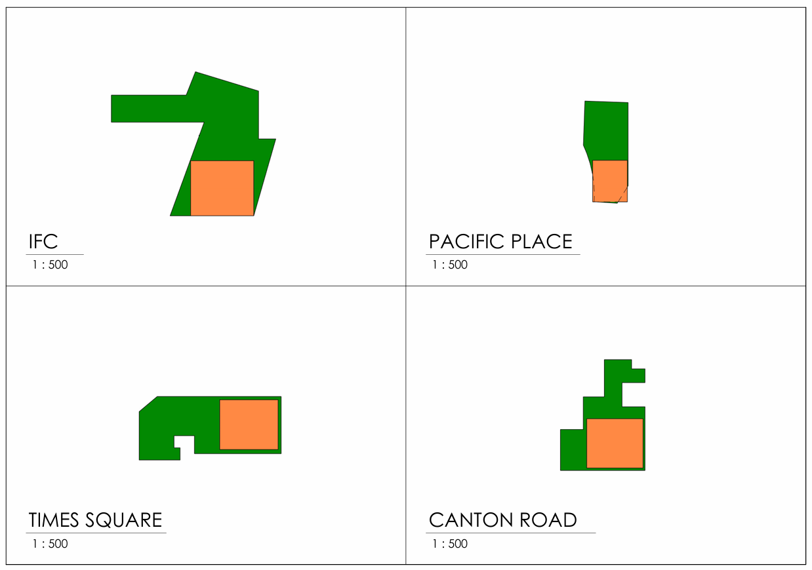

Mall-Specific "Hidden" Hurdles
While FEHD/FSD rules are standard, each mall (Wharf, Swire, SHKP) has its own Technical
Fit-out Guide:
Mall (Location) | Key Statutory/Mall Consideration
IFC (Central) | Stringent MEP coordination; high-spec smoke extraction requirements often exceed FSD minimums.
Pacific Place (Admiralty) | Known for strict acoustics and smell-mitigation (EPD) controls to protect nearby luxury retail.
Harbour City (TST) | Complex logistics for night-work and massive Fire Service Installation (FSI) network integration.
Times Square (CWB) | Focus on vertical transportation of waste and strict adherence to shared grease-trap capacities.

APPENDIX C: TEAM STRUCTURE: ORGANISATION CHARTS & CVs

Project Team - Organisation Chart

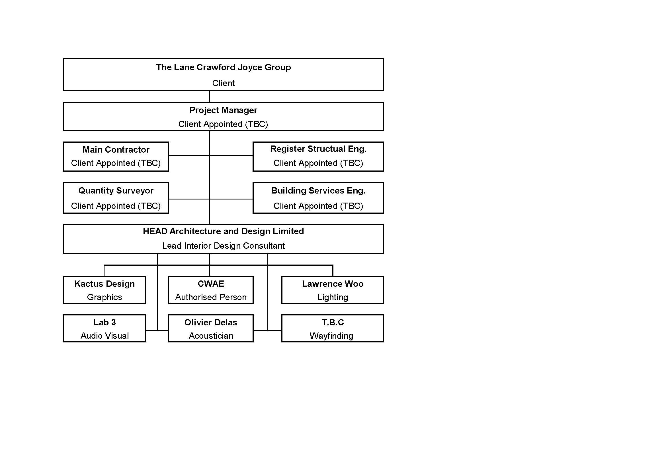
Note: Quantity Surveyor and Main Contractor to be appointed directly by the Client.

Project Delivery Team Requirements
To deliver four luxury F&B projects in Hong Kong on a 6-8 month fast-track timeline, a single, highly coordinated Project Delivery Team is essential.

1. Core Design & Creative Resources
- Design Lead (Creative Director): Responsible for the "one unifying modular design" and ensuring brand consistency across all four premium locations.
- Lighting Consultant: Crucial for "luxury" positioning. They handle lighting layouts, lux calculations for mall approvals, and mood settings to match high-end mall standards.
- Senior Interior Designers (x2): At least two senior designers are needed to handle the volume of four parallel sets of technical drawings and material boards.

2. Statutory & Licensing Resources (Legal Prerequisites)
- Authorized Person (AP): Legally required to certify building safety and sign off on FEHD/Buildings Department submissions.
- Registered Structural Engineer (RSE): Required if your "modular design" involves heavy fixtures or structural changes (e.g., new kitchen partitions or ceiling supports).
- Licensing Consultant: A specialist to manage the administrative FEHD (Food and Environmental Hygiene Department) application process, ensuring your Provisional License is secured in time for the 6-month launch.

3. Technical & Engineering Resources
- MEP Consultant (Mechanical, Electrical, Plumbing): Essential for F&B to handle grease traps, ventilation (to FSD/EPD standards), and fire service integration.
- Kitchen Consultant: Specialized in designing efficient F&B workflows, selecting professional-grade equipment, and ensuring the kitchen layout passes FEHD hygiene inspections.
- Fire Services Consultant/Registered Fire Engineer: To ensure all four sites meet mall-specific and FSD (Fire Services Department) fire safety requirements for the Fire Services Certificate.

4. Project Management & Execution
- Project Manager (PM): The "central engine" who coordinates with four different mall landlords, manages the aggressive 8-month timeline, and oversees the contractor.
- Quantity Surveyor (QS): Manages the budget across four sites, handles tendering for a single contractor to build the modular design, and controls fit-out costs.

HEAD Architecture and Design Team - Organisation Chart 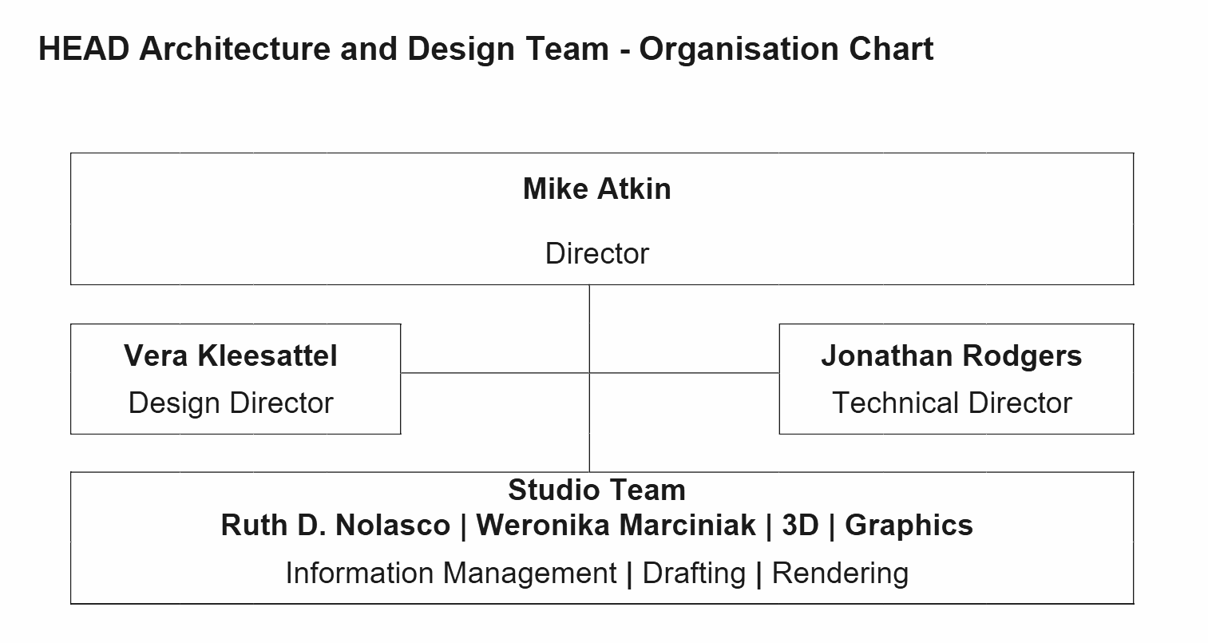
CV's attached below:
Mike Atkin
Jonathan Rodgers
Vera Kleesatel
Ruth D. Noscalo

Relevant Experience and Qualifications of Key Staff
Below is our proposed key staff for the project and a brief synopsis of the relevant qualifications and experience of our nominated project team.

Mike Atkin | Project Director
 | (BA (hons) BArch (Hons) DipArch, RIBA)
- 25 Years of design and project administration experience.
- An Architect with extensive experience in interior design. Mike has extensive knowledge of the Asia-Pacific region.
- Mike would act as the Project Director overseeing the overall management of the project. He would be the primary point of contact for the Client’s senior management.

Dr Vera Kleesatel | Design Director – Architecture, Interior Design, Fashion Design, Advertising
 | Dr. Dipl.-Ing. Arch. ARB (UK), AKH (D), HKIUD
- +20 years of design experience.
- A Senior Architect with extensive experience in architectural commercial and cultural design, documentation and site supervision.
- Completed projects in Hong Kong, China and UK, Europe
- Vera will be responsible for design direction and design quality review.

Jonathan Rodgers | Technical Director – Architecture & Interior Design,  Project Management & Coordinaton
 | BA(Hons) Bachelor Architecture APMP
- +20 years of architectural and interior design experience.
- BIM Project Manager and Coordinator with strong technical documentation skills and knowledge of local regulations.
- Completed projects in Hong Kong, China and UK.
- Jonathan will be responsible for project delivery, team
co-ordination and the Consultant and Contractor liaison.

Ruth D. Nolasco | Information Manager – Architectural Design BIM Specialist
- +20 years of architectural and interior design experience.
- Architectural Assistant with strong technical and documentation skills and knowledge of local regulations.
- Completed projects in Hong Kong, Macau and Philippines.
- Ruth will be responsible for drawing documentation and information management.

HEAD Architecture and Design Limited - Responsibilities and Degree of Involvement of Key Staff Showing Percentage of resources of key personnel of each stage summary

Team Member | Position | Stages 1-2-3 | Stage 4 Tender | Stage 5 Construction | Stage 6 Post Construction | Role
Mike Atkin | Project  Director | 40 | 30 | 20 | 10 | Mike would act as the Project Director overseeing the overall management of the project and be the primary point of contact for the Client’s senior management.
Jonathan Rodgers | Technical Director | 100 | 80 | 60 | 40 | Jon is responsible for Technical Design, site-supervision and liaison with Contractor, Consultants and Client.
Vera Kleesatel | Design Director | 100 | 80 | 60 | 40 | Vera is responsible for Creative Direction, Concept and Detail Design documentation,

Adequacy of Professional and Technical Manpower Input

Team Organization and Reporting Structure
The Organization Charts included in this proposal show the team organization and reporting structure. All participants and personnel are aware of how and where they fit into the consultant team and how they are expected to report the findings and output of their activities. They are experienced in their roles and have the correct technical support for the full studio team and project team of consultants at their disposal.
Responsibilities and Duties for Team Personnel
All team personnel have been made aware of the extent of their responsibilities and duties in particular the authority to discuss issues with the Client, government departments relative to their discipline and the timing and content of their individual deliverables and services.
We have a strong supporting team of Consultants and their information is shared in the following chapters and in the Appendices.

- Approach to Cost Effectiveness
- Examples of Past Projects that demonstrate that Consultants will have ability to produce cost effective procedures

HEAD Architecture has a proven track record as an award-winning design company, but also have an enviable repeat client base, due to our ability to project manage efficiently, controlling costs and minimising Variation Orders, while maintaining team stability throughout the duration of the project.

As we work with several large retailers, we understand the requirement for knowing market rates, so that prices can be fixed and carried across multiple projects that are running concurrently and in more than one country at any one time.

- Approach to achieve cost effectiveness, energy efficiency, environmental friendliness and green procurement

HEAD Architecture make all efforts will be made to source all materials locally, minimising the requirements for large carbon footprints.

Methodology and Work Programme
- Technical Approach

While we consider that an AP and RSE are not necessary for this project, the role of the MEP and Acoustic /AV consultants are essential to augment HEAD’s design and provide the level of comfort both environmentally and acoustically, to allow separation but also flexibility within both the teaching spaces and circulation area.
APPENDIX D: MASTER PROGRAMME - PROPOSED TIMELINE
The anticipated Master Programme is attached here for comment. Detailed programme showing all four sites with staggered milestones to be provided by Project Manager.
CNY Easter
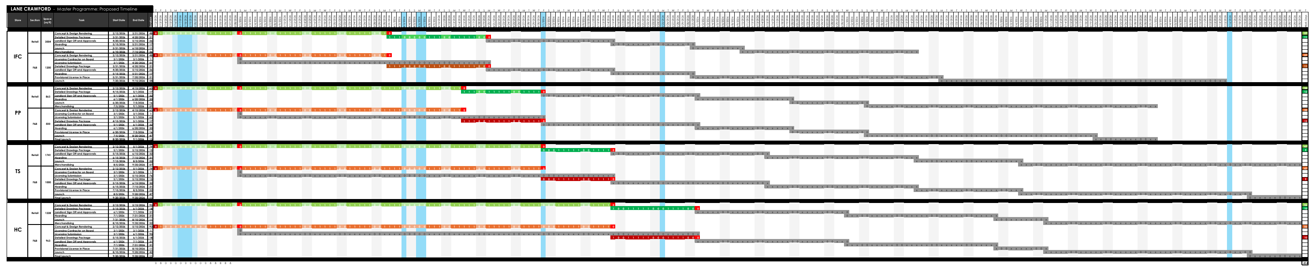
Start 12 Feb Mar Apr May Jun Jul Aug Sep Finish

> Concept Design > Branding > Graphics > DD > CD > TD > Construction > Supervise > Launch
The proposed timeline targets staggered launches across Q3 2026 (September 1-30), subject to landlord and statutory approvals. The programme is based on a FAST-TRACK SCHEDULE calculated on normal working days, excluding weekends and Hong Kong Public Holidays.
Indicative Key Milestones:
• Contract Award: February 2026
• Concept Design: February-March 2026
• Developed Design: March-April 2026
• Construction Documentation: April-May 2026
• Landlord/Statutory Submissions: May-June 2026
• Tender Period: June 2026
• Construction Period: July-August 2026
• Handover & Launch: September 1-30, 2026
Any programme acceleration beyond this fast-track schedule, additional design revisions, or repeat submissions required due to:
• Extended statutory authority response times
• Landlord review delays or additional requirements
• Changes in project scope or design brief
• Client-directed revisions beyond standard allowances
...may impact the level of effort required and will be reviewed accordingly. Additional services will be charged at the hourly rates specified in Appendix B (Clause 4.1).
Timeline Dependencies:
Project timelines depend on factors outside the design team's control:
• Landlord approval processes (varies by location)
• Buildings Department submissions (if required)
• FEHD licensing applications (coordinated with Food Licence Consultant)
• FSD approval processes (coordinated with Fire Services Consultant)
• Building management review cycles
• Client decision and approval windows (7-day approval period per stage)
Our approach minimises delays within our control and provides design documentation to support timely submissions. Programme dates are indicative and subject to adjustment based on approval timelines.

APPENDIX E: APPROACH AND METHODOLOGY

The following describes our design philosophy and delivery approach for the Lane Crawford Food Hall project.
Detailed scope of services, deliverables, and exclusions are defined in Section 4.

3.1 Our Strategic Approach: Designing at Three Speeds

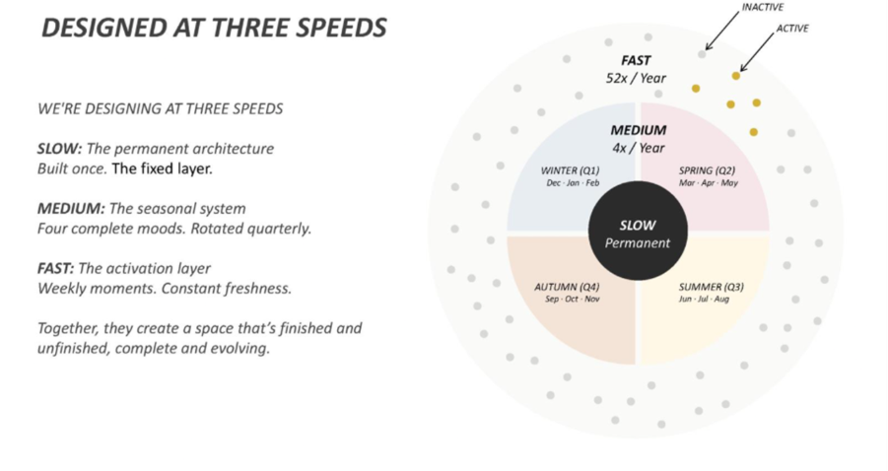Lane Crawford's food destinations support cultural programming, brand partnerships, and social experiences.

To support this, we design at three speeds:

Slow: The Permanent Architecture Built once. Never compromised.
- Spatial planning and circulation
- Core infrastructure (services, lighting grid, power)
- Hero materials and finishes • Fixed architectural elements (thresholds, soffits, feature walls)

Medium: The Seasonal System (Refreshed 4× per Year) Four moods. Designed
in advance. Rotated like fashion seasons.
- Quarterly display narratives and color palettes
- Rotational fixture configurations
- Seasonal graphics and wayfinding
- F&B concept refresh capability

Fast: The Activation Layer (Changed 52× per Week). Designed for content creation. Always fresh. Continuously evolving.
- Weekly brand drops and limited releases
- Pop-up zones for collaborations
- Event infrastructure (launches, tastings, content moments)
- Flexible promotion areas
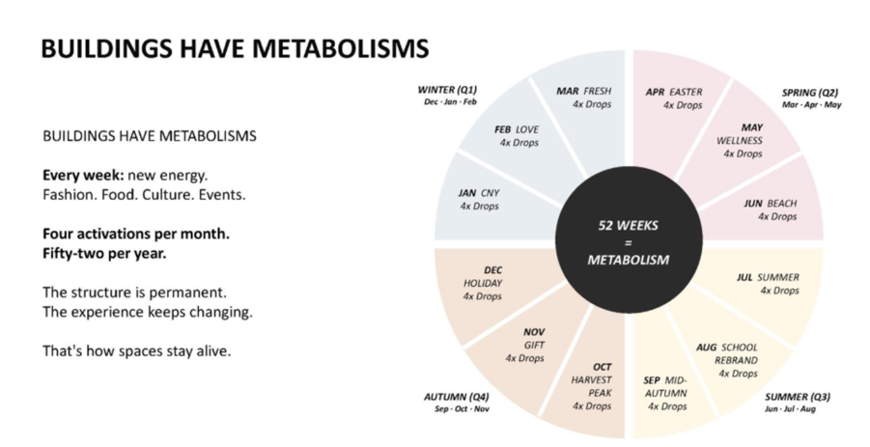The Result
This 'metabolism'; permanent skeleton, seasonal refresh, and weekly activations; ensures your spaces feel both complete and constantly evolving, maintaining design integrity while enabling operational agility.

3.2 Managing Four Sites, One Vision

The Challenge
- Four locations (10,500 sq ft total)
- Four landlords with different approval requirements
- Staggered launch window (September 1-30, 2026)
- Requirement: Design consistency + coordinated delivery

Our Framework

Phase 1: Unified Concept Development
- Single umbrella design concept across all locations
- Spatial planning principles (circulation, zoning, sightlines)
- Material and finish palette
- Fixture design language
- Brand identity and graphics system (coordinated with branding consultant)
- Modular component library (enables parallel site adaptation while maintaining design consistency)

Phase 2: Parallel Site Adaptation
- Simultaneous development of four location-specific designs
- Independent documentation sets (prevents cross-contamination of delays)
- Shared detail library (reduces duplication)
- Central design coordination (maintains consistency)

Phase 3: Coordinated Execution
- Parallel construction across sites where feasible
- Site supervision during critical phases
- Cross-site learnings applied to optimise delivery

3.3 Fast-Track Delivery Framework

The Challenge
- ~8 months from contract to first launch
- Overlapping design phases required
- Multiple approval authorities (landlords, BD, FEHD, FSD)
- Coordination across specialist consultants

Our Acceleration Strategy
Fast-Track Delivery (Without Compromising Design Quality)
- Overlapping design phases where feasible
- Early landlord engagement and pre-submission consultations
- Decision-ready presentations for efficient approvals
- Streamlined approval documentation to support statutory submissions

Design Documentation & Coordination
HEAD Architecture provides comprehensive design documentation and coordinates with separately appointed specialist consultants:
- Documentation prepared to FEHD/FSD/landlord requirements to facilitate statutory submissions
- Design information provided to support the Buildings Department submissions (if required)
- Proactive coordination with MEP, Kitchen, Fire Services, and Food Licensing consultants (as appointed) to prevent redesign loops
- Hong Kong landlord experience (IFC/PP/HC/TS) applied to anticipate approval requirements

Risk Management
- Independent documentation per site (prevents delay and cross-contamination)
- Early coordination with consultants to identify issues
- Design progress monitoring and proactive communication
- Documentation quality control to support approval processes

Timeline Dependencies

Project timelines depend on factors outside the design team's control:
- Landlord approval processes (varies by location)
- Buildings Department submissions (if required)
- FEHD licensing applications
- FSD approval processes
- Building management review cycles
- Client decision and approval windows

Our approach minimises delays within our control and provides design documentation to support timely submissions. Programme dates are indicative and subject to adjustment based on approval timelines.

3.4 Design Integrity Through Construction

The Challenge: Design concepts often dilute during contractor execution through value engineering and site compromises.

Our Quality Framework Proactive Oversight
- Site attendance during critical construction phases
- Material mock-up reviews before installation
- Direct contractor coordination throughout construction

Design Control Points
- Material approvals at the procurement stage
- Fixture prototype review before fabrication
- Critical installation oversight (finishes, lighting, branding elements)

Documentation & Handover
- Construction phase documentation and photography
- Defects coordination with the project team
- As-built drawing coordination

When issues arise, we solve them, not just report them. We maintain design integrity throughout construction.

Summary
This framework, unified concept, parallel execution, specialist coordination, and construction oversight, delivers four Lane Crawford destinations for Q3 2026 launches (subject to statutory approvals).

Our Hong Kong Retail Experience:
- Regulatory landscape (FEHD/FSD/BD requirements)
- Luxury mall standards (IFC/PP/HC/TS approval processes)
- Contractor realities (timeline and budget constraints)

We maintain design integrity throughout delivery, enabling launch readiness as approvals allow.

